https://www.fatmedia.co.uk/blog/11-psychological-theories-to-improve-your-content-marketing/:
11 Psychological Theories that will Improve Your Content Marketing
Contents
1. Social Proof 2
How do you apply the social proof theory to content marketing? 2
2. Scarcity 3
How do you apply the scarcity theory to content marketing? 3
3. Frequency Illusion 4
How do you apply the frequency illusion theory to content marketing? 4
4. The Endowment Effect 5
How do you apply the endowment theory to content marketing? 5
5. Reciprocity 7
How do you apply the reciprocity theory to content marketing? 7
6. Confirmation Bias 8
How do you apply the confirmation bias theory to content marketing? 8
7. Paradox of Choice 9
How do you apply the paradox of choice theory to content marketing? 9
8. Loss Aversion 10
How do you apply the loss aversion theory to content marketing? 10
9. Mere-Exposure Effect 11
How do you apply the mere-exposure effect theory to content marketing? 11
10. The Decoy Effect 13
How do you apply the decoy effect theory to content marketing? 13
11. Information-Gap Theory 14
How do you apply the information-gap theory to content marketing? 14
Final Thoughts 15

Social Proof

Above: The origins of contemporary subcultures such as ‘hipsters’ are found in social proof. Image by Jay Mantri
Principally, social proof is a psychological phenomenon that makes you adopt the beliefs or mimic the actions of a group of people you like or trust. In many circles, this is known as the ‘me too affect’, and it all boils down to the fact that us humans love to follow the behaviour of others. How else would you explain the violent eruption of some horrific fashion trends and the proliferation of contemporary subcultures like ‘hipsters’?

How do you apply the social proof theory to content marketing?
There are many ways you can use social proof to improve your business’ content marketing. For example, adding social plugins and sharing buttons to your blog will display the number of shares a piece of content has generated. If readers can see that some people have shared your post already, they are a lot more likely to follow suit themselves.
Moreover, user-generated content like reviews, testimonials and social media mentions each offer fantastic avenues for leveraging social proof. This is because they all highlight the positive experiences of your happy customers and signal to others your business or product is trustworthy. Therefore, if you are lucky enough to boast these or any other forms of social proof, you should do everything you can in your power to promote them.

Scarcity

Above: Rare bottles of whiskey made during World War II that are worth more because of their scarcity. Image by Mikael Leppä
In social psychology, the theory of scarcity dictates that as humans we put a higher value on things that we believe are scarce and a lower value on things that are in abundance. This theory is also used in the discipline of economics in relation to supply and demand, which proposes the rarer a product is, the more it is worth.

How do you apply the scarcity theory to content marketing?
When shopping on Amazon for a new book, how many times have you seen the words: ‘only 1 left in stock – order soon’? This is Amazon using the theory of scarcity to their advantage, and countless other businesses exploit a similar tactic.
If you can prove to customers that your content is rare, they will automatically perceive it to be more valuable. For example, if you create an ebook, you can give it away for free for a limited time or on a first-come, first-served basis.
Alternatively, if you have a mailing list, you could consider sending your customers a personalised email. This will provide you with the opportunity to remind people they only have ‘X’ amount of days to sign-up for your free ebook, podcast or whatever piece of content you want to promote.In short, there are many ways you can use the concept of scarcity to your advantage in content marketing, but you might have to think creatively.

Frequency Illusion

Above: You know when you see a product for the first time and then it appears everywhere you look? That’s frequency illusion. Image by Steven Lewis
Frequency illusion, otherwise known as the Baader-Meinhof Phenomenon, is where something that people have just learnt or noticed for the first time starts to appear everywhere they look.

How do you apply the frequency illusion theory to content marketing?
When developing a content marketing strategy, you should aim to create integrated campaigns. Just as no man should be an island, neither should a single piece of content be within your marketing strategy.
You should create multiple pieces of content across numerous platforms that reinforce the marketing message conveyed in each and create the feeling of frequency illusion for your customers. Above all, though, benefiting from frequency illusion is about creating relevant, engaging content that blends digital, traditional and social media marketing into one, greater whole.

The Endowment Effect

Above: Endowment theory means that we value things we own more than they are actually worth. Image by DaMongMan
The endowment effect is a theory used in behavioural economics to explain the phenomenon of why people value things they own more highly.
Arguably, the most famous experiment into the endowment effect was carried out in 1980 by the economist Richard Thaler with a class of students at Cornell University. He gave half the students in his class a coffee mug and then encouraged them to trade it with their classmates who did not receive a mug.
Despite receiving their coffee cups for free, the students holding the mugs set their minimum prices too high, and those not holding mugs set their maximum bids too low. Therefore, because of the endowment effect, very little trading took place.

How do you apply the endowment theory to content marketing?
According to the endowment theory, your customers attribute a higher value to your product because they already own it. For this reason, you should create a content marketing strategy that increases and reinforces their sense of ownership for your product, post purchase.
For example, encouraging feedback and suggestions across your social media platforms can help customers to share experiences about your business and strengthen positive feelings. Creating blogs, ebooks and other content that helps customers get the most out of their purchase can also help maximise their perception of value.
In essence, these types of strategy increase the influence of the endowment effect on your customers and the position of your brand or product at the forefront of their minds.

Reciprocity

Above: If you are welcoming to others, the theory of reciprocity proposes they are more likely to be friendly back. Image by alborzshawn
In social psychology, reciprocity is responding to the positive or kind actions of others with a positive or kind action yourself. For this reason, if you are friendly or welcoming to people, reciprocity ensures that people are far more likely to be welcoming and friendly back. The reverse is true of unfriendly actions, where the reciprocal response can be even more extreme.

How do you apply the reciprocity theory to content marketing?
Giving something away to your customers for free is a fantastic technique for building customer loyalty. In a way, content marketing is the perfect example of using the reciprocity theory to your advantage. If you think about it, with every blog post you create, you are giving away valuable insights to your customers for free – or at least that’s what you should be aiming to do.
You can go a lot further than writing blog posts to take advantage of reciprocity, though. You can create podcasts, webinars or ebooks, which is a tactic that Copyblogger have leveraged with great success. Alternatively, if your business is suited, you can offer your product on a free trial for a limited basis like Netflix, Spotify and countless other brands do.
In short, if you can make your customers feel special with your content, reciprocity will help you create brand loyalty for your business.

Confirmation Bias

Above: Do you actively seek evidence that supports your views while ignoring evidence that doesn’t? Confirmation bias suggests you do. Image by Jimmie
In psychological theory, confirmation bias is where people seek out information that supports their views whilst ignoring evidence that doesn’t. Or in others words, when it comes to confirming their pre-conceptions or self-hypothesis, many people are biased in their selection of supporting evidence.

How do you apply the confirmation bias theory to content marketing?
Find out about the positive perceptions that your customers hold about your business and produce content that reinforces them. Furthermore, making an effort to understand confirmation bias within your customer segments can help you produce more relevant content for specific and targeted niches.
Conversely, if you are trying to combat negative confirmation bias about your business, you will need to support all claims made within your content with cold hard facts and concrete research. If you use untested opinion or hearsay to try and reverse negative confirmation bias, you will struggle to get your customers to believe in your content.

Paradox of Choice

Above: Shall I go left or right? The paradox of choice theory suggests you should limit the range of choice provided to customers. Image by sacks08
In marketing, providing people with freedom of choice is often seen as positive because it offers customers full autonomy over their decisions. However, if you give customers too much freedom of choice it can have an adverse effect. Barry Schwarz’s paradox of choice suggests that providing consumers with a limited range of choices has psychological benefits because it reduces anxiety for shoppers.

How do you apply the paradox of choice theory to content marketing?
Don’t overwhelm your customers by providing them with too many choices, or too much information to digest. Instead, consider producing marketing materials that concentrate on a maximum of three key points at a time. This extends to the creation of calls-to-action for your content, where less is often more. So where possible, provide customers with just one or two clear paths to follow after they have consumed your content, in order to avoid them making no choice at all.

Loss Aversion
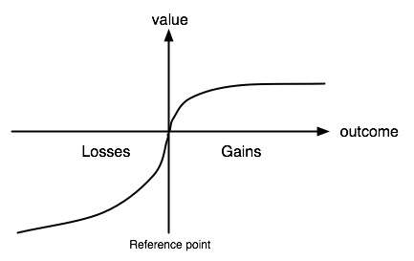
Above: This graph illustrates the psychological phenomenon of loss aversion. Image by AJC ajcann
In the behavioural decision theory (BDT) branch of psychology, loss aversion refers to the tendency that most people prefer avoiding losses rather than acquiring gains. Many studies, including this one by the Ross School of Business, University of Michigan, suggest that the hurt associated with loss is twice as powerful as good feelings associated with gain.

How do you apply the loss aversion theory to content marketing?
The simplest way to apply loss aversion to your content marketing strategy is to discover what makes your customers tick. If you can learn their greatest fears, you can produce content that highlights the benefits of your product that will remove those doubts from their consciousness.
For instance, if the main benefit of using your product is time saving, produce content that illustrates to customers how many hours your product can give back to them. Similarly, if your product’s main benefit is money saving, produce content that highlights just how much people can save.
In a nutshell, narrow down what benefit your product or service provides, figure out how it can ease people’s fears, and then create a content strategy around those two things.

Mere-Exposure Effect
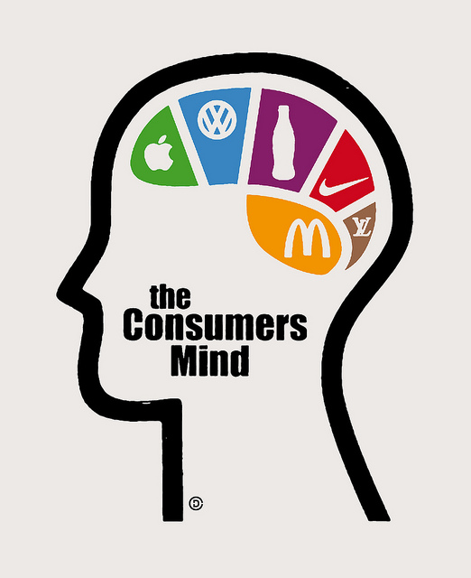
Above: Because we are familiar with big-name brands, we subconsciously hold a preference towards them. Image by Christopher Dombres
Fundamentally, the mere-exposure effect is a psychological occurrence whereby people display a preference for things because they are familiar. The crux of the mere-exposure effect is that as humans, we warm to associations of comfort and familiarity. So, when faced with the choice between two opposing products – one we are familiar with, and one we are not – more often than not we will pick the one we are familiar with.

How do you apply the mere-exposure effect theory to content marketing?
Traditionally, only the bigger brands, that could afford to launch advertising campaigns across a huge array of mediums, could benefit from the mere-exposure effect. However, with the advent of social media more businesses than ever can get their message in front of people.
Therefore you should not miss the chance to spread your brand-based content as far and as wide as possible. Exploit social media, repost and share content as much as possible. This way, when customers begin their purchase decision process, they will already be familiar with what your business can offer them.

The Decoy Effect

Above: By introducing a third less attractive option, the decoy effect is designed to take advantage of price comparison shoppers. Image from Google Images
The decoy effect is a psychological occurrence that means consumers are more likely to change their preference between two options when a third less appealing option is introduced. In short, the decoy effect works best when taking advantage of comparison shoppers.

How do you apply the decoy effect theory to content marketing?
Think about when you buy popcorn at the cinema. There will be a large disparity between the prices of the small and the large cartons, but the large carton will only be slightly more expensive than the medium one. In this scenario, the medium carton is the decoy, designed to make the large, most expensive carton of popcorn appear more attractive to customers. When creating product pages for your business you can take advantage of the decoy effect by using the same principle for your pricing strategy.

Information-Gap Theory

Above: The easiest way to encourage an information-gap is to craft a headline that encourages curiosity. Image by Cory Doctorow
In psychology, the information-gap theory of curiosity develops when we feel there is a gap between what we know and what we want to know. The theory, developed by George Loewenstein in the early 1990s, proposes that we have a strong emotional response when faced with an information-gap. In effect, this feels like a mental itch that you can only scratch by acquiring information that provides you with what you need to know.

How do you apply the information-gap theory to content marketing?
In brief, you will need to create content that generates curiosity with your audience and then provides knowledge that fills the information-gap created. The easiest way to create curiosity in your content is by crafting attention-grabbing headlines.
Created by Michael Masterson, the 4U’s formula for creating effective headlines states that all headlines should be unique, ultra-specific, useful and convey a sense of urgency. So when fashioning a headline, test out a variety of options until you find a combination that encompasses each of the four U’s. Then, of course, your content must make good on the promise of the headline and provide the reader with the new knowledge that they desire.

Final Thoughts
There are a large number of facets to creating a content strategy that works. However, using psychological theories to consider how your customers think and what content might work as a result can help you cut through the huge volume of digital marketing noise we’re all bombarded with.

